Skin Graph-t

Tech Writer: Dean Gladish - Richard Yan

Engineer: Mitchell Mikinski

Reporter: Richard Yan

Conductor: Everyone :P

You have a lot of correct answers here, which shows great understanding of graph properties. Nice work! Your justification for graph A is very thorough and well-written. It seems that you are a bit confused about the definitions of independent sets and bipartite graphs. We may go over this a bit more in class, or feel free to ask Doug, Lizzy or me to clarify.  
  
You should provide brief descriptions of the rest of the graphs, to explain where your numbers are coming from. In addition, some of your answers need a sentence or two of justification. What properties are you using to decide whether a graph is Hamiltonian? Eulerian? Bipartite?

--RK

Graph A: Looks good - Lizzy

Graph B: Actually, this graph is Eulerian--can you see why? The rest looks good.--RK

Graph C: All good except omega and Theta - Lizzy

Graph D: All good!--RK

Graph E: You seem to be exactly incorrectly +1 on all of your answers, from Chi-Theta. - Lizzy

Graph F: This one is bipartite--does it have any odd cycles? The other values you calculated are correct.--RK

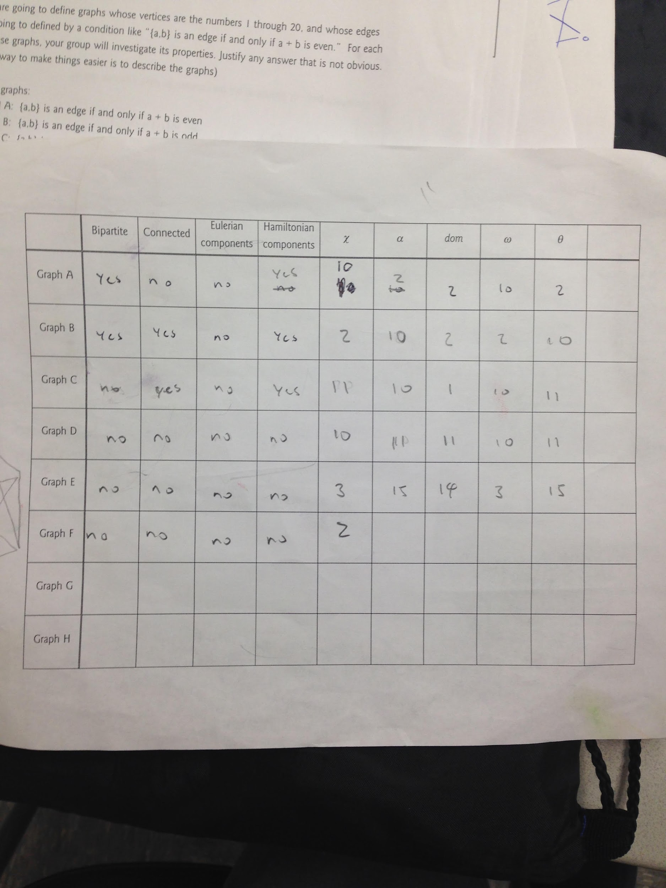

Morning Report: This morning we did not discuss much, instead, we were handed a packet of quantities to solve. For example: show a graph and a graph’s complement where 𝜔(G) > *dom*(Gc) or where 𝛳(G) > ɑ(Gc). We spent the entire morning solving these kinds of problems. At first it was difficult to understand, and instead of (G) > (Gc) some students did (G) >(G) instead.

Afternoon Report: This afternoon, we worked together to complete our problems. The work wasn’t difficult, so much as it was time consuming. It was basically taking eight different graphs and seeing how nine different properties were applied to each graph. This was helped by the teamwork we added. Every person would contribute ideas, the group vetted them, and then we came to consensus. Our group also worked on planarity in the computer lab. Problem one, while not particularly entertaining, helped everyone in the group gain a much deeper understanding of our five quantities.

Graph A: The graph is bipartite because we have two independent sets - evens and odds, which are separated because they are not connected to each other as the addition of an even number and an odd number is odd. Since all even numbers are connected to even numbers, and all odds are connected to odds, the graph’s chromatic number would be 10 as there would be two complete graphs of order 10. The independence number would be 2, because there are two complete sets and we can only take one from each set. The domination number would also be 2, as one vertex from each of the 2 complete sets would be necessarily connected to every other vertex in the set. The clique number would be 10, as the total number of even/odd integers is 10. There would be two partitions.

Mitchell completed level 7 on planarity and ended with a score of 709. Richard completed level 7 with a score of 678. Dean completed level 6 on planarity.